1. In last lecture, we saw how to start sh immediately a container is started.
2. To come out of the shell, you can type CTRL + D or exit command.
3. 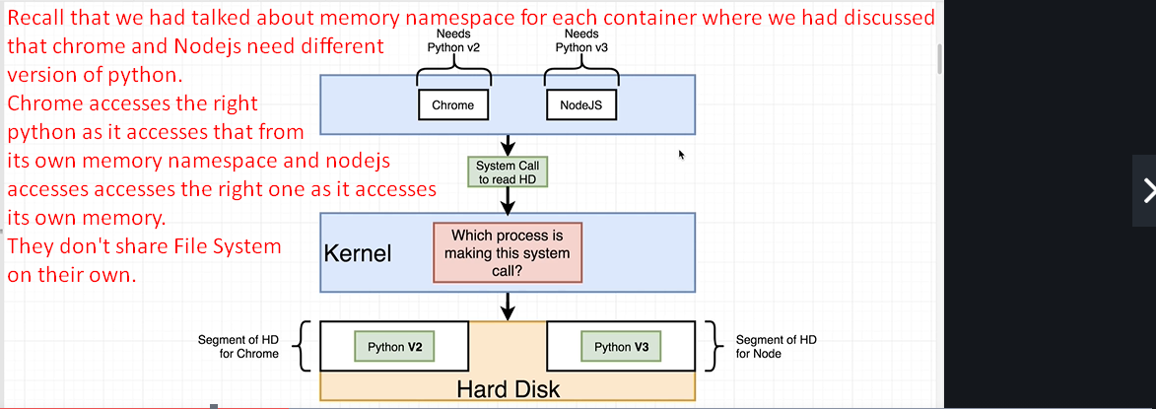
4. Let’s see this by practical example by creating two same processes.
5. 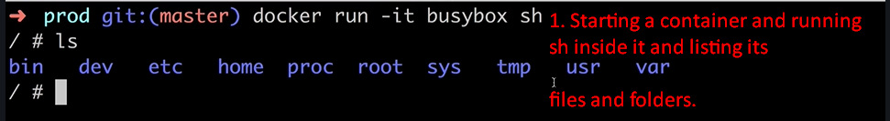 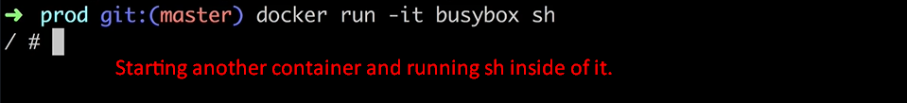
6. 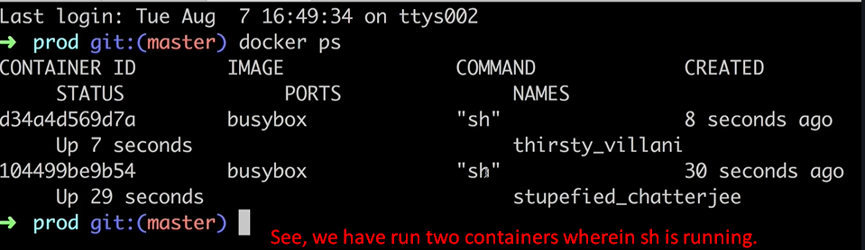
7. 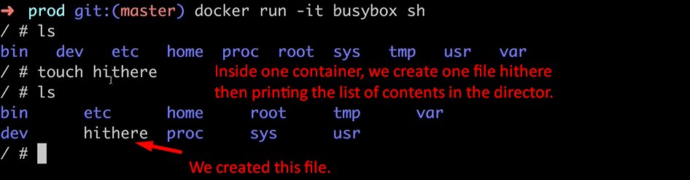
8. 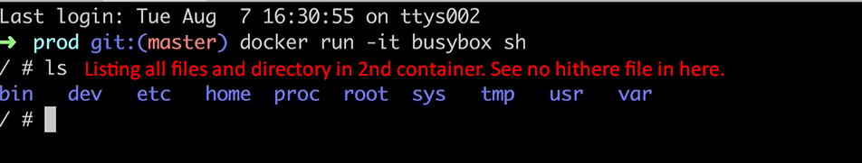
9. This is because those two containers have absolutely separate file systems and there is no sharing of data b/w them.